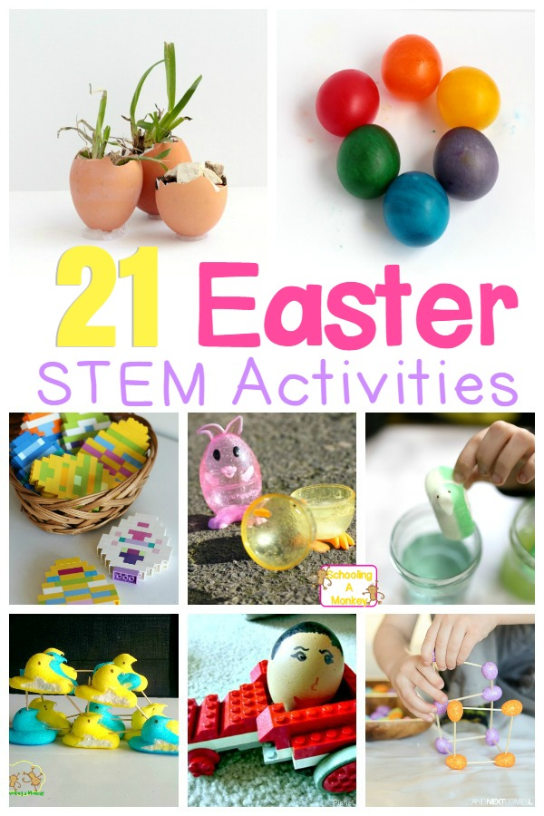
Easter is an exciting time for most kids. Capture this excitement and boost STEM skills with these Easter STEM activities!
Easter is an amazing time for STEM and science lovers because there are so many ways to learn with eggs, candy, and Peeps! Kids of all ages will adore these Easter STEAM activities perfect for home, the classroom, or homeschool activities!

Related: Peeps STEM and Science Activities
21 Exciting Hands-On Easter STEAM Activities for Kids
Kids will love these adorable Easter STEAM activities!
Egg Drop STEM Challenge from Schooling a Monkey
Egg Shell Gardens from Schooling a Monkey
Peeps STEM Activities from Schooling a Monkey
Peeps Engineering Challenges from Schooling a Monkey

Peeps Science Experiments from Schooling a Monkey

Soap-Powered Peeps Boat from Schooling a Monkey
Peeps Boat Building Challenge from Schooling a Monkey
Peeps Density Experiment from Schooling a Monkey
Rubber Egg Rainbow from Schooling a Monkey
LEGO Egg Racers from Planet Smarty
Egg STEM Investigation from Little Bins for Little Hands
Jellybean STEM Structures from And Next Comes L
Egg Shell Tinker Tray from Lemon Lime Adventures
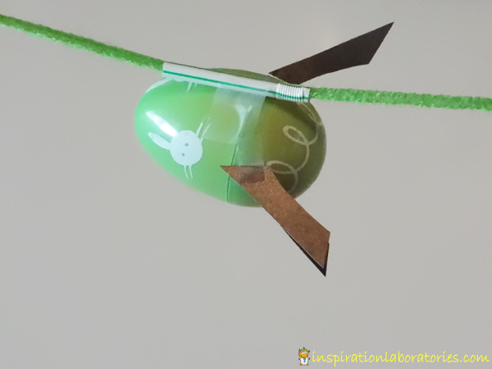

Easter Tinker Basket from Little Bins for Little Hands

LEGO Easter Eggs from Little Bins for Little Hands
Support the Peeps STEM Challenge from Little Bins for Little Hands
Easter Egg Rockets from Inspiration Laboratories
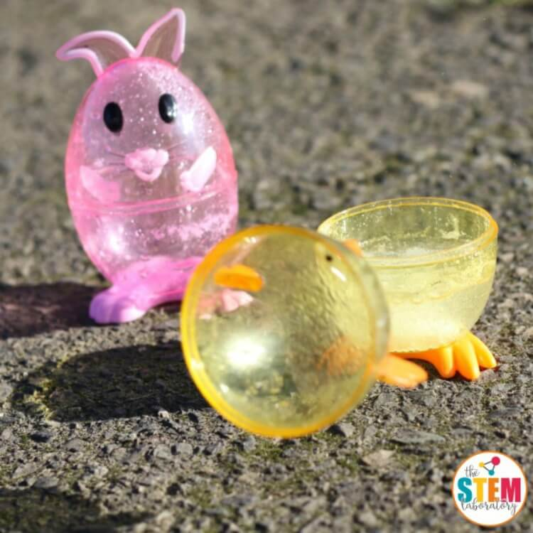
Peeps Catapult from Playdough to Plato
Exploding Easter Egg Rockets from The STEM Laboratory
Dissolving Peeps from Lemon Lime Adventures
Making Eggs Grow and Shrink from Science Sparks

